

2021

Winner Takes It All



Game design document – v2.0

Vasco Correia, 50039633

Tomasz Wasilonek, 20210246

Summary

1. Introduction 3

2. Game world and level design 4

3. Camera 6

4. Gameplay 7

4.1. Movement phase 7

4.1.1. Energy 9

4.2. Combat phase 10

4.3. Inventory 10

5. Weapons 12

5.1. Club (default) 12

5.2. Knife 12

5.3. Throwable bricks 12

5.4. Hand bomb 13

6. Front End 14

7. Graphics 15

7.1. Particle systems 15

8. Assets (3D, 2D) 17

8.1. Character 17

8.2. Weapons 17

8.3. Game World 17

8.4. Music/Sfx 18

9. Networking, matchmaking, multiplayer online spec 18

# Introduction

This is a multiplayer turn-based game playable over the internet by 2 players.

Winner Takes It All was created in Unreal Engine 4.27 and targets the Windows operating system.

Players are thrown into a terrain encircled by mountains. There is a possibility to gain freedom if the convict takes part in a last-man-standing type of tournament and of course - wins it all. **Winner takes it all.**

Playersenter a match where they must strategize their movement and actions to be the last one surviving.

It combines strategy and exploration of the environment to find the best spot on the map and good loot that will allow the player to defeat the other player.

Inspiration image taken from: https://www.adventurerooms.it/en/escape-medieval-prison-opens-pavia/

# Game world and level design

The map will be made of a terrain.

For the vertical slice the team will create a level using the Unreal Engine 4 terrain tool. The map will be surrounded by mountains which are not climbable by the players.

Placed around the level there will be weapon loot that the player can collect. These will be placed randomly around the map. The terrain will have elevations, that can be used by the players to be able to see more of the map.

In the centre of the map there is a very big elevation that can be used to see a lot of the map. It also has one of each weapon loot.

Each player is placed in one of the corners of the level this way they must walk around the level and collect some loot before engaging in a fight.

Levels will be designed in a way that gives players the possibility to find the best strategic positions for each map, that will allow them to use their available weapons.

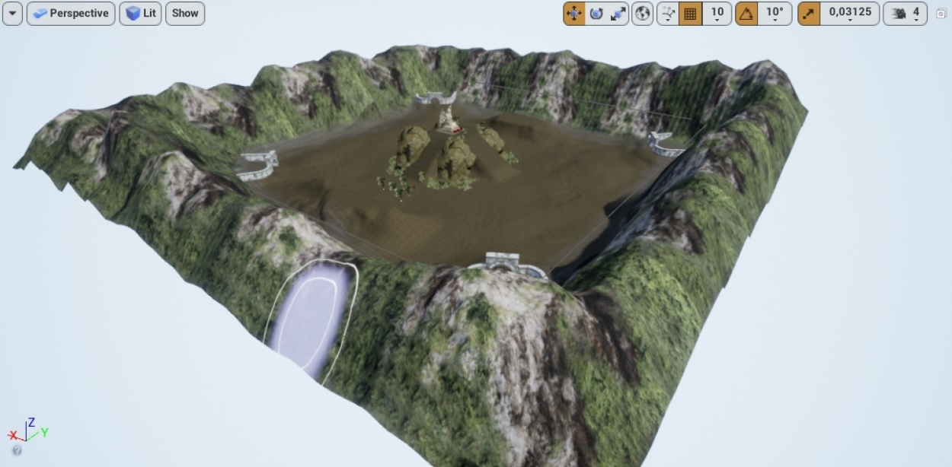

Terrain of Winner Takes It all prototype

# Camera

The camera is similar to a Real Time Strategy game. The camera is intended to be like RTS games like Civilization V or Warcraft III.

It is an isometric camera with a bird’s eye view.

The player can move the camera by placing the cursor in the edges of the game window, but it has a limit of 200 units to each direction so that the player cannot see each other unless they are somewhat close

Although the camera can be moved freely, it can also snap back to the player character if the player presses the spacebar key.

Camera from Winner Takes It All

# Gameplay

The Player after connecting to a match will be randomly assigned to a predefined position on the map and from there the game starts for him.

The core gameplay is organized into 2 stages that are repeating in a loop until only 1 player is left alive:

## Movement phase

The movement phase is the first phase in the gameplay.

For movement a navigation mesh that covers the entire terrain is used. When a player clicks somewhere where the click is detected his character will move to that position.

Players will have a maximum amount of "Energy" that they can spend to move.

This stage lasts for **10 seconds** until every player has made his decision.

In this phase the player will be able to see the maximum range that he can travel. This is indicated by the green circle under the player.

He can now choose strategically what he wants to do before trying to engage in combat, and his weapons, can play a role in what he chooses.

**The player should use this phase to:**

1. take a good position to see other players or to hide from attacks if he can't see other players.
2. find loot.

**There are 3 major restrictions for the player:**

1. The phase has 10 seconds.
2. The players have a maximum amount of energy (i.e. how far can he go)

**Examples of choices and trade-offs for the player:**

1. Going to higher ground and so he has a higher probability to see. However, this is a long journey, so it may take him more than 1 turn to arrive there, and he might need to resign from picking up loot nearby to save energy to get there.
2. The player can decide to hide behind an obstacle.

After this phase is complete the game moves to the **combat phase.**

### Energy

At the start of each movement phase each player will have 6 energy points to spend. The number of points he has is indicated in the UI under the Health Points.

The player is not forced to spend all his energy points.

Each point of energy corresponds to one second of movement. So, the player can move for 6 seconds on the movement phase.

## Combat phase

In the combat phase players will have the option to attack each other.

This stage lasts for 10 seconds.

The players have different weapons. Some of them are close-range (knife, club) and others long ranged (throwable bricks, bombs).

The player has the option to attack a player or to do nothing in the case he prefers, for example, to remain hidden.

Each player can only do one attack on each combat turn. After that the attack button in the UI is disabled preventing the player from executing another attack.

After the stage is complete (time passes or decisions are made), the attacks are executed.

**The player should use this phase to:**

1. Decide if they want to attack other players and with what kind of weapon.

## Inventory

Each player will have an Inventory with 4 slots. There is no limit to the amount of ammunition a player can hold for each weapon.

This means that a player can have as much “bricks”, “bows” or other weapons as he collects.

Inventory

# Weapons

Weapons can be collected around the map. They are essential for the success of the player. When a weapon is collected it goes to the player’s inventory.

When a player collects a weapon, they can be used as many times as he wants.

Below are listed all types of weapons planned to be implemented.

## Club (default)

The default weapon. All players start with this weapon in the beginning of the match, and it has unlimited uses.

|  |  |  |
| --- | --- | --- |
| Damage | Range | Sprite |
| 1 unit | 200 units |  |

## Knife

|  |  |  |
| --- | --- | --- |
| Damage | Range | Sprite |
| 3 unit | * 1. units |  |

## Throwable bricks

An efficient weapon that can attack at a distance.

|  |  |  |
| --- | --- | --- |
| Damage | Range | Sprite |
| 2 unit | 700 units |  |

## Hand bomb

A high damage weapon that can be used at a medium distance.

|  |  |  |
| --- | --- | --- |
| Damage | Range | Sprite |
| 3 unit | 600 units |  |

# Front End

In game UI

* 1. Phase indicator and timer – Shows the current phase the game is in and how much time left there is for it end
  2. Attack menu – When clicking on a enemy this menu will show. The player can choose which weapon to use on the attack by clicking on its image and then click on attack to attack the player that was clicked
  3. Health and Energy bars – Show how much health points and energy points the player has
  4. Inventory – In the inventory the player can see the weapon that he has already collected

# Graphics

The graphics are intended to have a slightly dark theme since the players are being held prisoners.

The colours intended for the game are darker colours.

# Assets (3D, 2D)

All the assets were acquired online.

## Character

Each player has a model of a prisoner. There are 3 animations for the character, idle movement phase, idle combat phase and running.

## Weapons

Ideally, we will need a model for each of the weapons in the game. Additionally, we will need 1 sprite for each weapon so that they can be identified in the inventory (these are already acquired).

So, we need:

1. Club model
2. Knife model
3. Throwable brick model
4. Hand bomb model

The team wasn´t able to implement models for each of the weapons.

## Game World

To create the terrain 7 textures are used: two for grass, two for the cliffs, one for roads and two for dirt.

There are also Rock, walls, arcades, statue and vegetation static meshes that were used.

## Music/Sfx

The team could not find the time to add music and sound effects to Winner Takes it All.

# Networking, matchmaking, multiplayer online spec

The multiplayer logic will be divided into three different parts:

* Client-side
  + The game package that players install and play
  + Each player’s package will connect to the Matchmaking service through the internet and ask for connecting to a game session
* Matchmaking service
  + Receives incoming requests from the Clients
  + It checks for existing Game servers that have free slots for new players
    - If it can find one, it sends that server’s IP address to the player, and allows for connection
    - If it can’t find one, it spawns a new Game server, and sends it IP to the Client.
* Game server
  + Starts / Ends game
  + Manages all game-related logic that needs to be synchronized (position of the players, amount of world discovered, collected loot etc.)